Login to your Parent Portal:
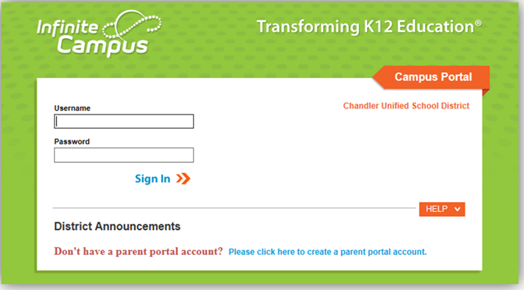
If you do not have an account, click on the “Please click here to create a parent portal account.”
Once logged in, click More on the left side of the screen, and then choose InTouch Fee Payments:
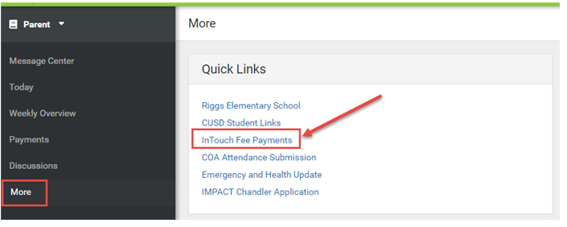

Choose the student that you are purchasing/paying for:
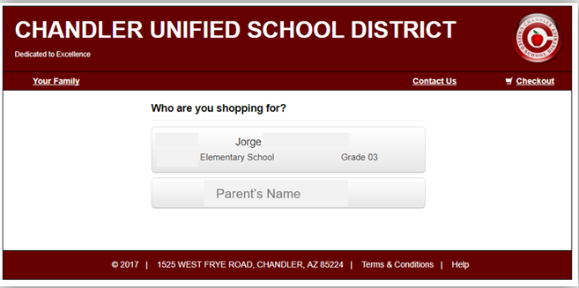
Next hit the View button to see outstanding fines/fees:
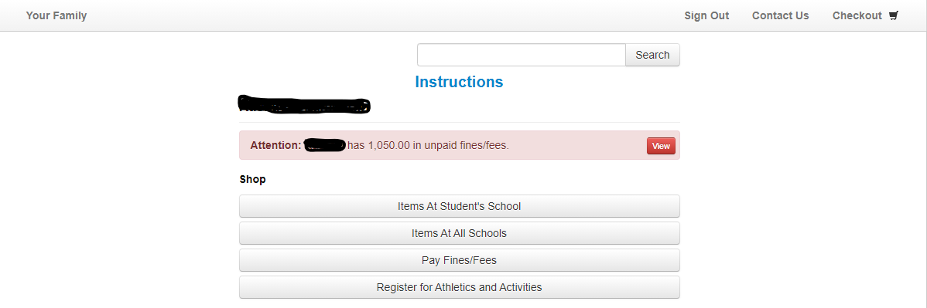

If you are making a partial payment, before you choose the item you are paying for, change the Amount Due to the amount you would like to pay:
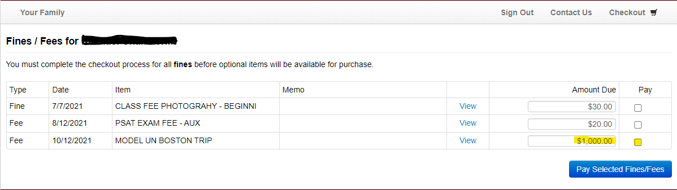
Next check the box next to the amount that you just entered and hit the Pay Selected Fines/Fees button:
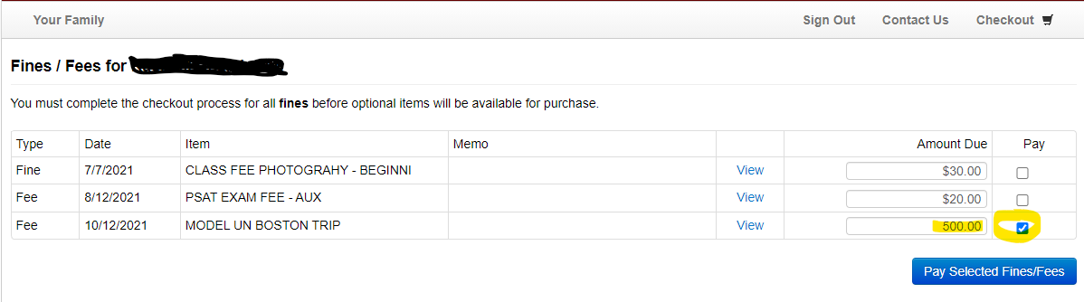
If you are ready to checkout, choose the Checkout button to complete your purchase. If not, choose the Continue Shopping button:
